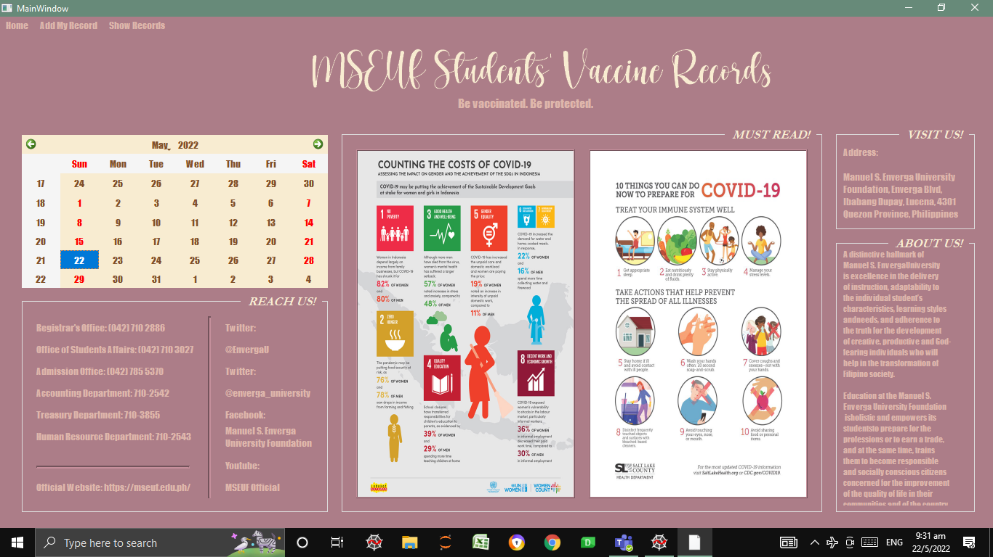

My Information system is a system that collects students’ records that is specifically made to prepare for the face-to face classes. The main window ist a collection of information about our school, MSEUF. There is also infographics about the Covid-19 to give knowledge and advices to the students. I also included a calendar so the users could see the date today, and also for a more attractive look.

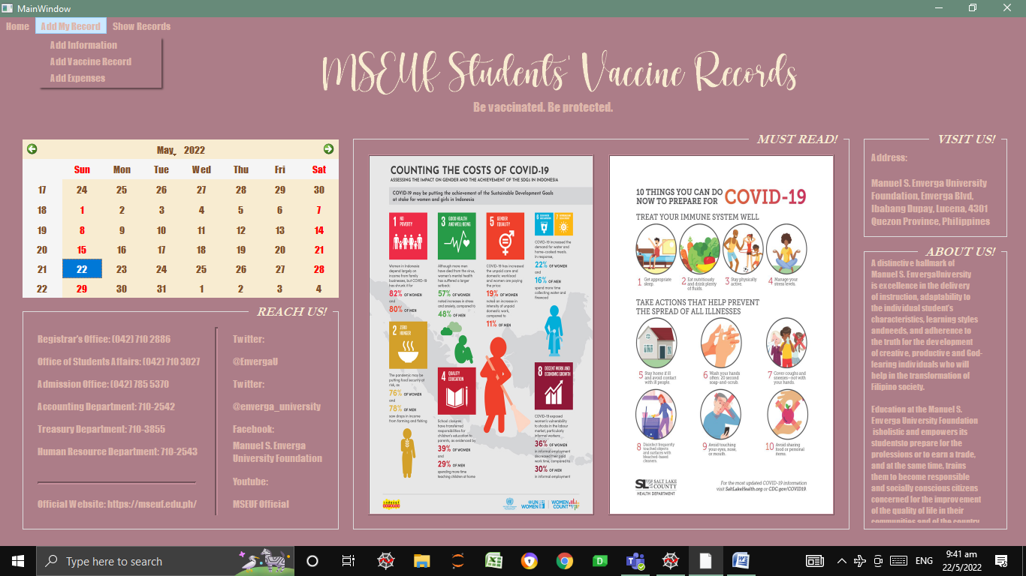

When the “Add My Record” button on the menu bar is clicked, three buttons would appear which are named “Add Information”, “Add Vaccination Record”, and “Add Expenses”.

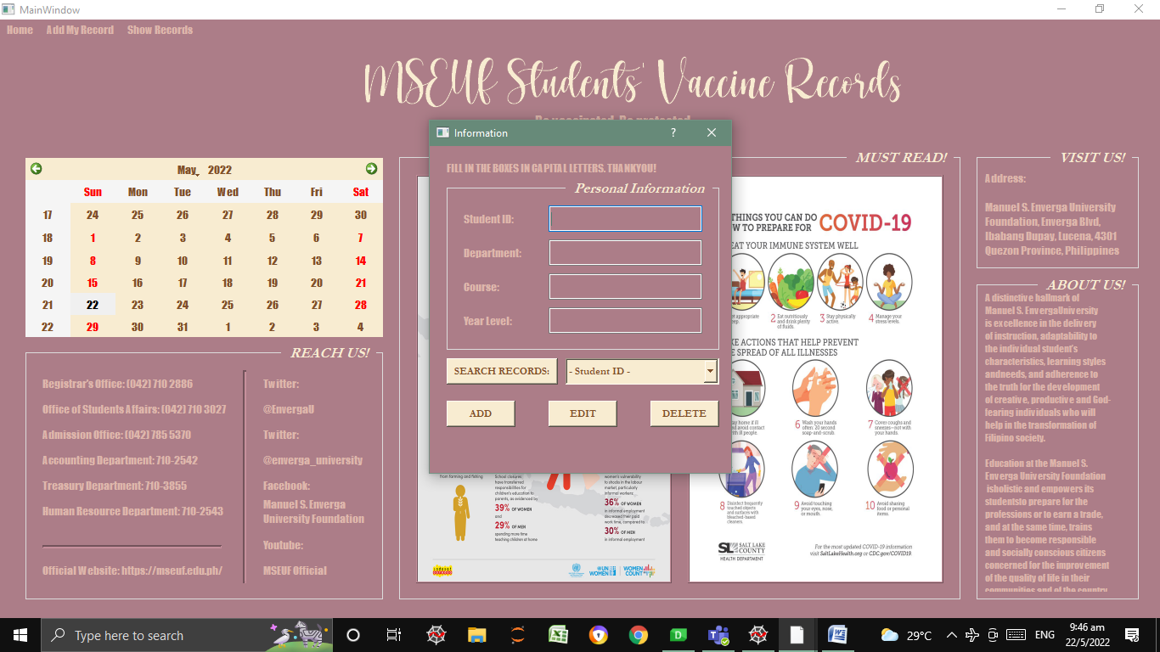

When the “Add Information” is clicked, a dialog box named “Information” would appear. The dialog box asks for the users’ personal information such as student ID, department, course, and year level. The purpose of this dialog box is to see the students enrolled in MSEUF.

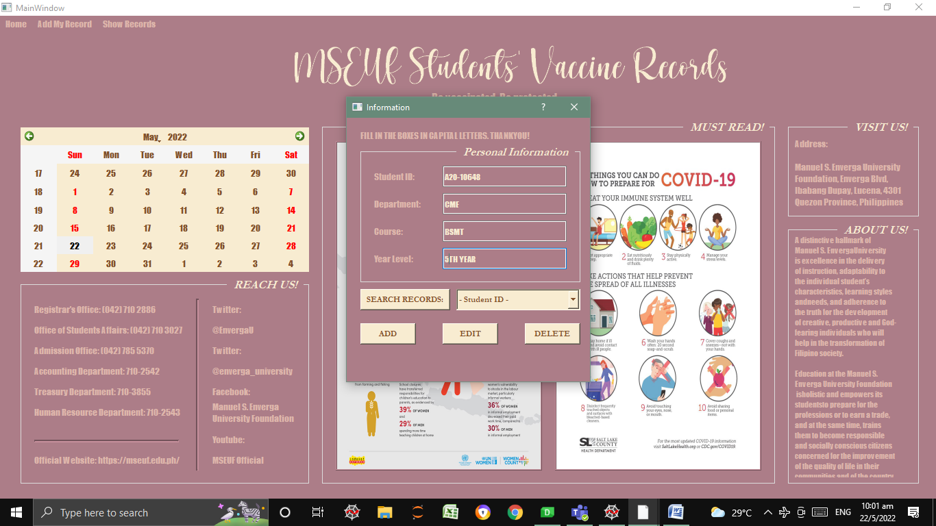 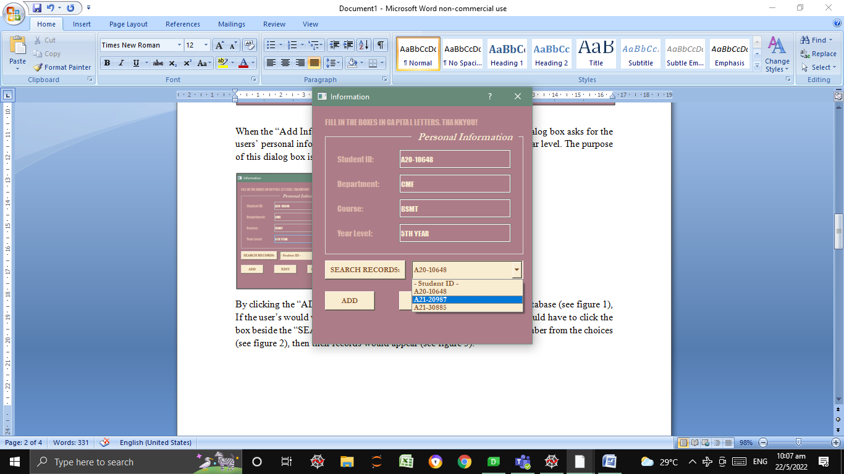 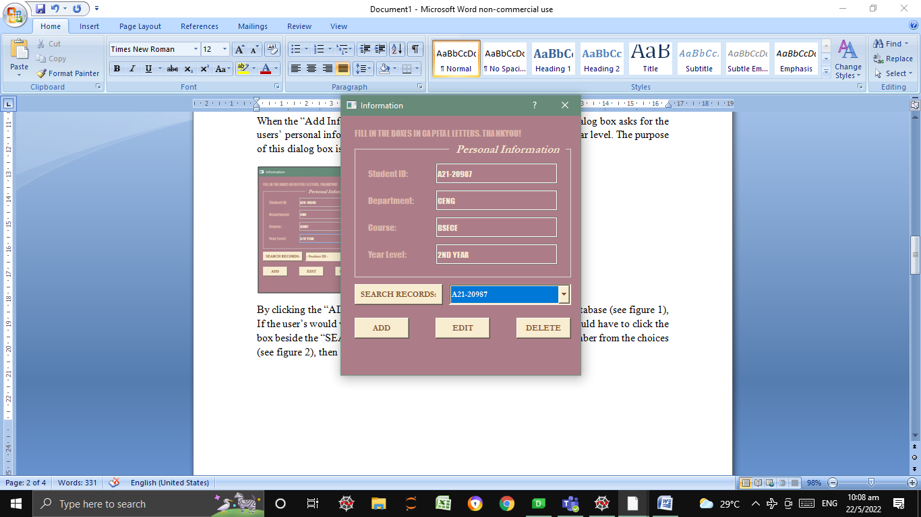

Figure 3

Figure 2

Figure 1

By clicking the “ADD” button, the user’s input would be recorded in our database (see figure 1), If the user’s would want to look for their record to view them, the user would have to click the box beside the “SEARCH RECORDS” button, and choose their student number from the choices (see figure 2), then their records would appear (see figure 3). The user could now edit their record by deleting and replacing the info that were already inputted in the boxes, then they would need to click the “EDIT” button so that it would be saved to our database. If the user would like to delete their records, they would have to click the “DELETE” button.

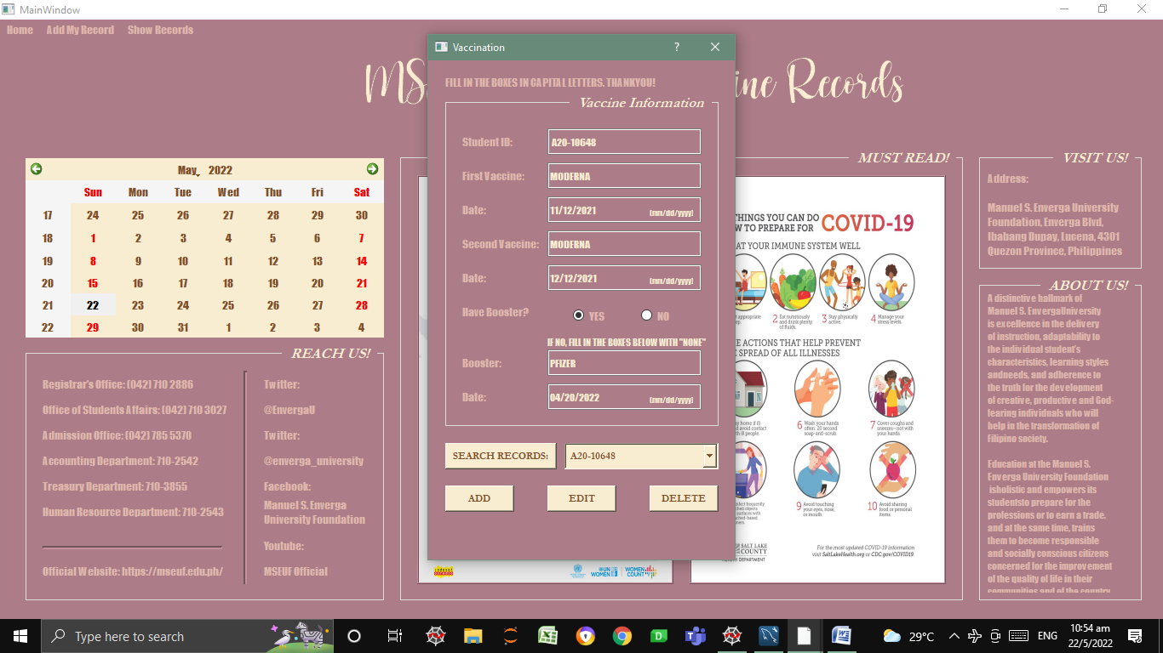

When the “Add Vaccination Record” is clicked, a dialog box named “Vaccination” would appear. The dialog box asks for the users’ vaccination record such as the type of vaccination and booster they’ve received, and the dates they’ve received them. The purpose of this dialog box is to see which students have received their vaccines and boosters. The instructions to search, add, edit, delete their records is the same as the instructions for “Add Information” dialog box.

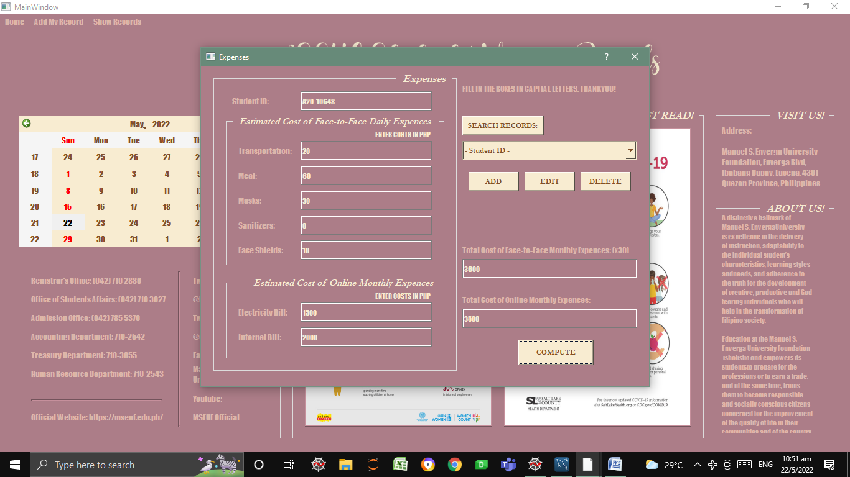

When the “Add Expenses” is clicked, a dialog box, named “Expenses” would appear. The dialog box asks for the users’ additional expenses that they would have if classes where to be conducted online and face-to-face. The user would have to click the “COMPUTE” button to see the total amount of their expenses. The face-to-face daily expenses are multiplied to the number of days in a month, 30, so that it could be fairly compared to the online classes monthly expenses. The purpose of this dialog box is to see which is more beneficial for the students’, financially. The instructions to search, add, edit, delete their records is the same as the instructions for “Add Information” and “Add Vaccination Record” dialog box.

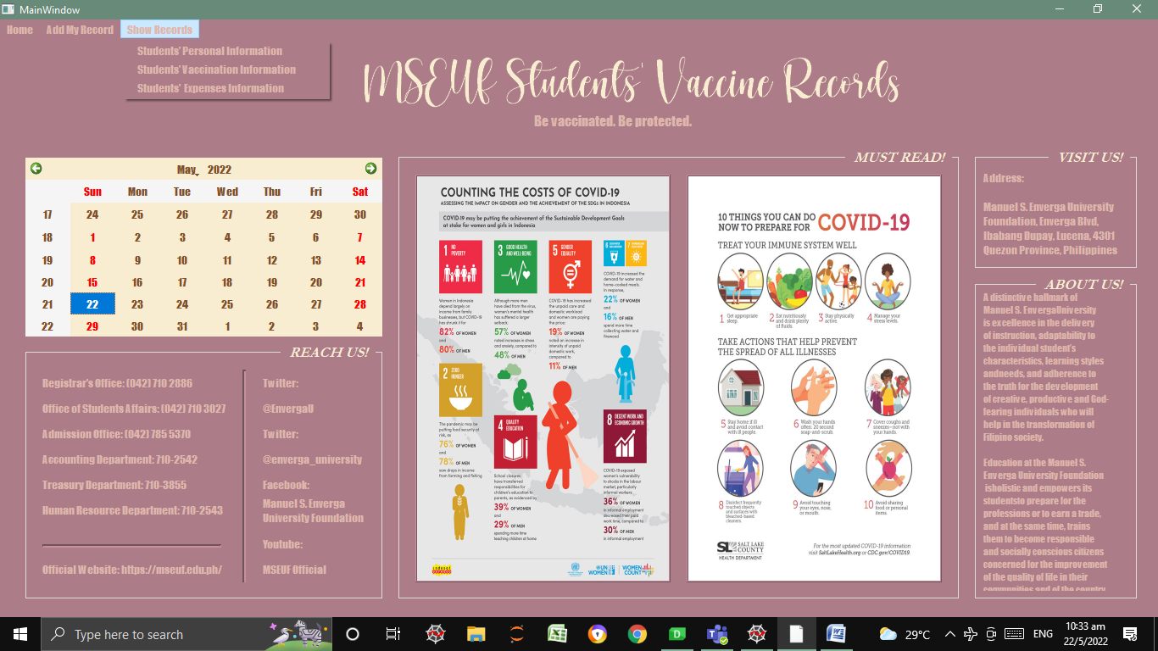

When the “Show Records” button on the menu bar is clicked, three buttons would appear which are named “Students’ Personal Information”, “Students’ Vaccination Information”, and “Students’ Expenses Information”.

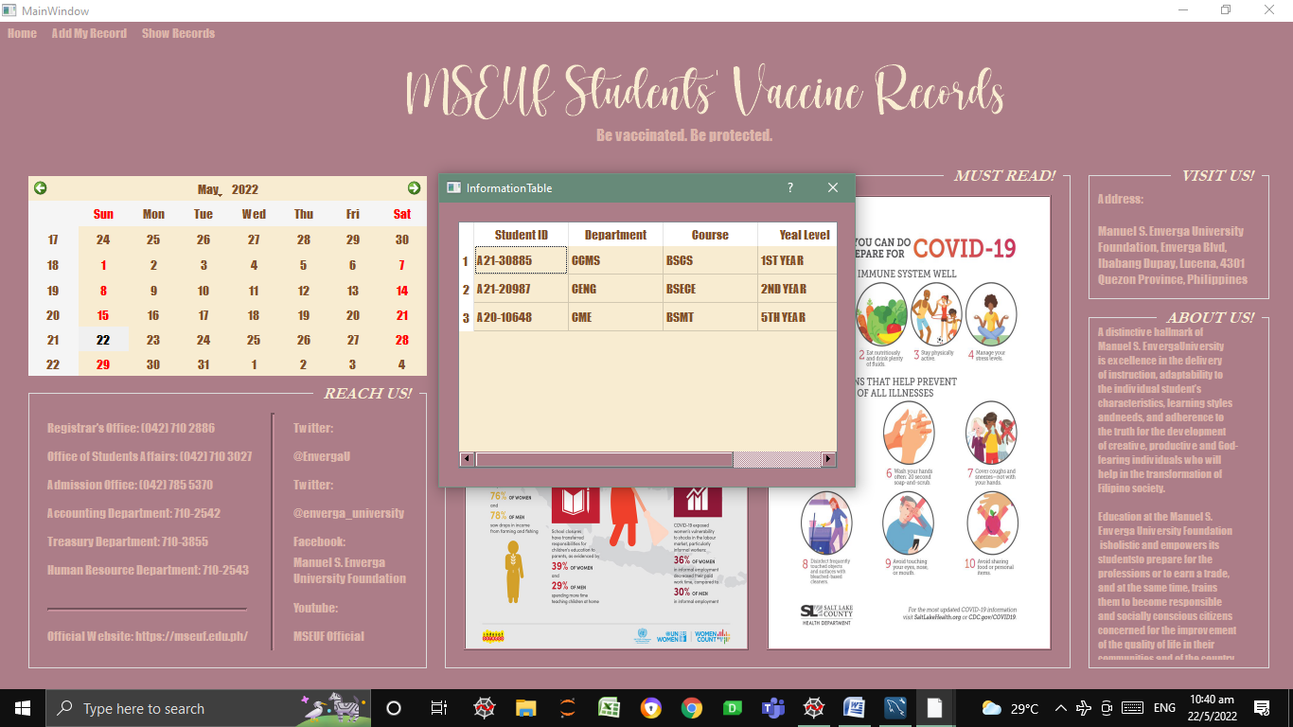

When the “Students’ Personal Information” is clicked, a dialog box named “InformationTable” would appear. The dialog box shows all the information that was added in the “Information” dialog box from the Add My Records > Add information. The information is grouped by or ordered by the students’ department.

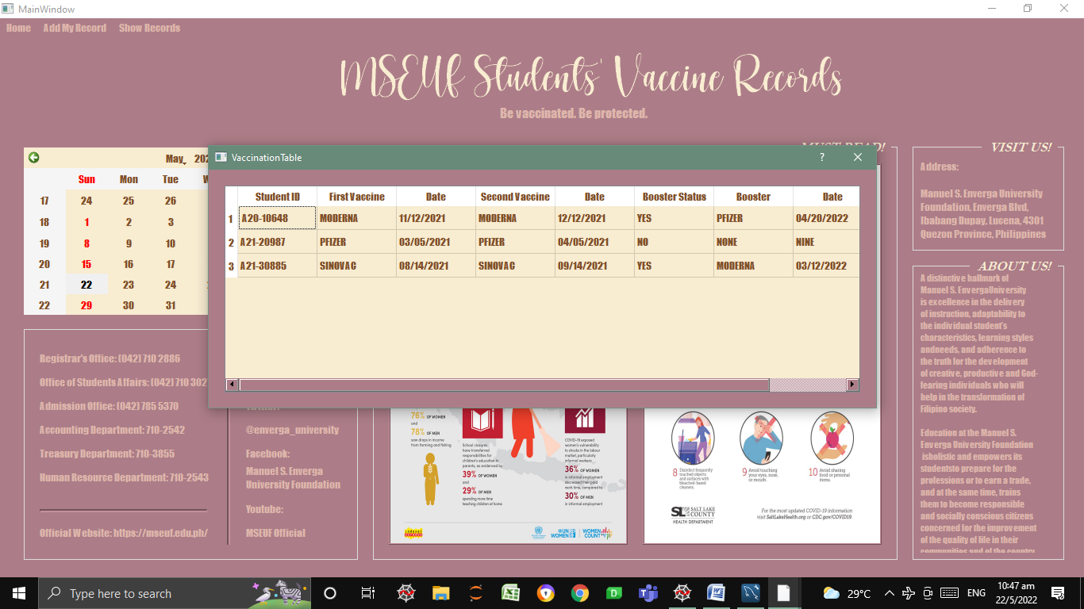

When the “Students’ Vaccination Information” is clicked, a dialog box named “VaccinationTable” would appear. The dialog box shows all the information that was added in the “Vaccination” dialog box from the Add My Records > Add Vaccination Record.

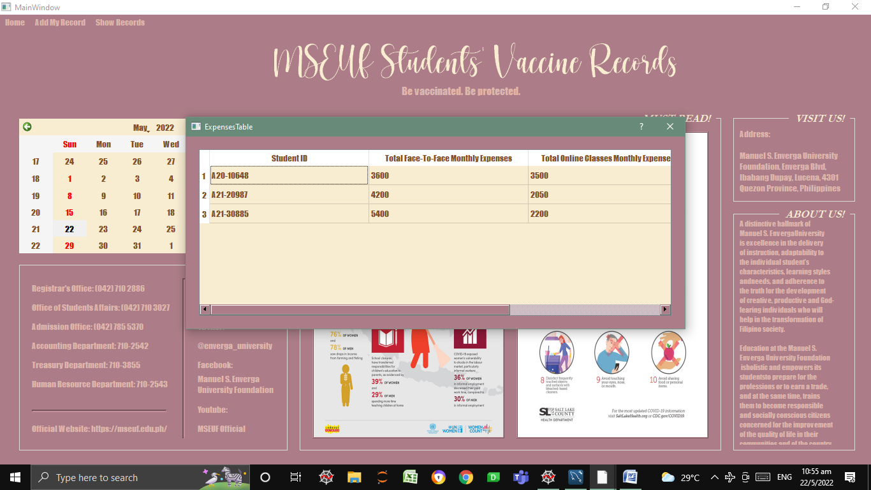

When the “Students’ Expenses Information” is clicked, a dialog box named “ExpensesTable” would appear. The dialog box shows all the information that was added in the “Expenses” dialog box from the Add My Records > Add Expenses.